

**SALES ANALYSIS OF MAVEN MARKET**

**BUSINESS CHALLENGE**

Maven market requested a KPI to track sales, revenue, profit, returns, cost sales regional performance and to identify high-value customers.

**GOAL**

To develop a visualization dashboard with maven market key performance indicators (KPIs).

**OBJECTIVES**

* To improve sales strategies
* To minimize returns
* Maximize profit
* To provide clarity for business executives to make the best business decisions

**SOLUTION DELIVERED**

**Step 1:**

**Created a mock-up of the questions to be answered on the dashboard**

* What is the total revenue?
* What is the total cost?
* What is the total quantity sold?
* What is the total quantity returned?
* What is the total profit?
* What is the revenue target?
* What is the quantity sold target?

**Step 2:**

**Assessed data for quality and completeness in preparation for analysis**

**Step 3:**

**Developed KPIs and performed analysis on the dataset with Power BI**

| KPIs | Measures |
| --- | --- |
| Total revenue | [Quantity] * [product_retail_price] |
| Total cost | [Quantity] * [product_cost] |
| Quantity sold | Total number of quantities sold |
| Quantity returned | Total number of quantities returned |
| Total profit | [Total revenue] – [Total cost] |
| Revenue target | [Total Revenue]*1.1 |
| Quantity sold target | [Previous Month Quantity Sold]*1.1 |

**Step 4:**

**Data Model created in Power BI to connect the data and define relationship <see screenshot>**

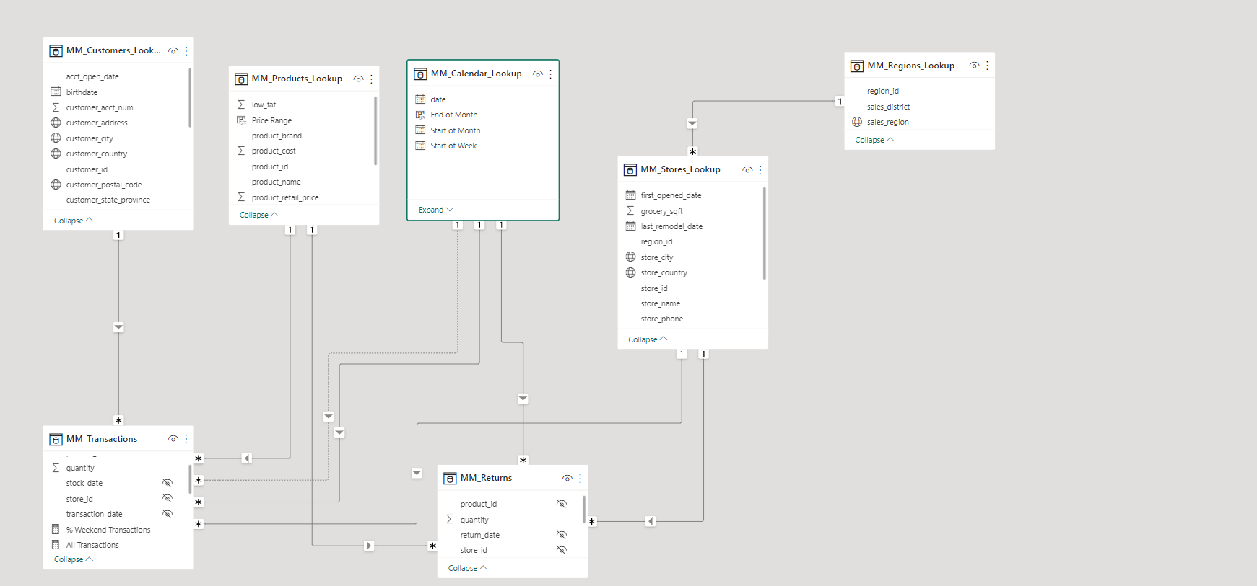

**Step 5:**

**Developed DAX functions and calculations**

* Total Quantity Sold = SUM(MM_Transactions[quantity])
* Total Revenue = SUMX(MM_Transactions,MM_Transactions[quantity]*RELATED(MM_Product_Lookup[product_retail_price]))
* Quantity Returned = SUM('MM_Returns_1997-1998'[quantity])
* Total Cost = SUMX(MM_Transactions,MM_Transactions[quantity]*RELATED(MM_Product_Lookup[product_cost]))
* Total Profit = [Total Revenue]-[Total Cost] Revenue Target = [Total Revenue]*1.1
* Quantity Sold Target = [Previous Month Quantity Sold]*1.1

**Step 6:**

**Created final dashboard using Power BI visualization tools**

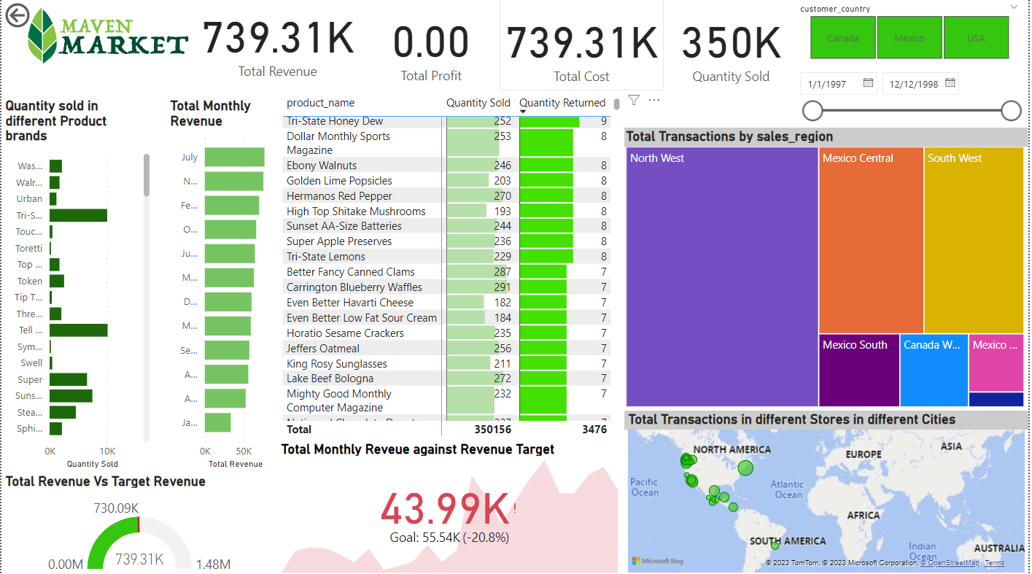

**BUSINESS INSIGHTS**

* Maven market generates total revenue of ($739.31K) compared to the targeted revenue of ($730.09K) which is categorized as a good performance
* Amongst the regions of operation, the North West has the highest revenue of ($54,696)
* Amongst the quantity of the product brand sold, hermanos brand sold the highest quantity of (24,682) with a revenue of ($24.074K)
* The customers in the USA generate the highest revenue ($495.15K)